Service discovery and Load Balancing demo:
🚀 1. What is Service Discovery?
🔍 The concept
When you have many microservices (e.g., User Service, Payment Service, Order Service) running on many machines (or containers), how do they find each other?
- Static approach: You hardcode IPs or hostnames.
✅ Easy, but bad when you scale or restart services (IP may change).
- Dynamic approach (Service Discovery):
Each service registers itself to a service registry (like Eureka, Consul, or Kubernetes DNS).
When another service needs it, it queries the registry to get the current IP.
💡 Real-world analogy
Imagine you want to call your friend’s new mobile number.
- With static config, you wrote the old number in your diary. If your friend changes the number, you’ll call the wrong person.
- With service discovery, you dial a central directory (like a phone directory service) that tells you the current number.

⚖️ 2. What is Load Balancing?
🔄 The concept
When you have multiple instances of a service (say, 3 copies of Payment Service), a Load Balancer distributes incoming requests among them.
This ensures:
- No single server is overwhelmed.
- Better utilization of resources.
- Better uptime (if one fails, traffic is routed to others).
💡 Real-world analogy
Imagine customers arriving at a bank.
- A person at the entrance (Load Balancer) directs each customer to one of several available counters (service instances) so no single counter is overloaded.

🔥 3. Combined Flow
- Service discovery lets services find each other’s current location.
- Load balancer spreads traffic across multiple instances.
E.g. Your Order Service queries a service registry (like Consul), gets the list of all Payment Service instances, and sends requests via a client-side load balancer (like Netflix Ribbon or Spring Cloud LoadBalancer).

Java-project/
├── eureka-server/
│ ├── src/
│ ├── pom.xml
│ └── application.properties / application.yml
│
├── demo-service/ (your product service)
│ ├── src/
│ ├── pom.xml
│ └── application.properties
│
├── order-service/
│ ├── src/
│ ├── pom.xml
│ └── application.properties

Explanation of each folder:

Folder | Purpose
eureka-server | This is your service registry. All other services register themselves here.
demo-service | This is your product service, running on 8081, 8082, etc.
order-service | This is your client service, which calls demo-service via Eureka discovery.

🚀 Commands to run each service
✅ Navigate into each folder and run:

✅ 1️⃣ Run Eureka server
cd D:\spring-project\Java-project\eureka-server
mvn spring-boot:run
✔ Opens on http://localhost:8761

✅ 2️⃣ Run two instances of demo-service
cd D:\spring-project\Java-project\demo-service
In two separate terminals:
# Terminal 1
mvn spring-boot:run -Dspring-boot.run.arguments="--PORT=8081"

# Terminal 2
mvn spring-boot:run -Dspring-boot.run.arguments="--PORT=8082"
✅ Both will show up in Eureka as DEMO-SERVICE (2).
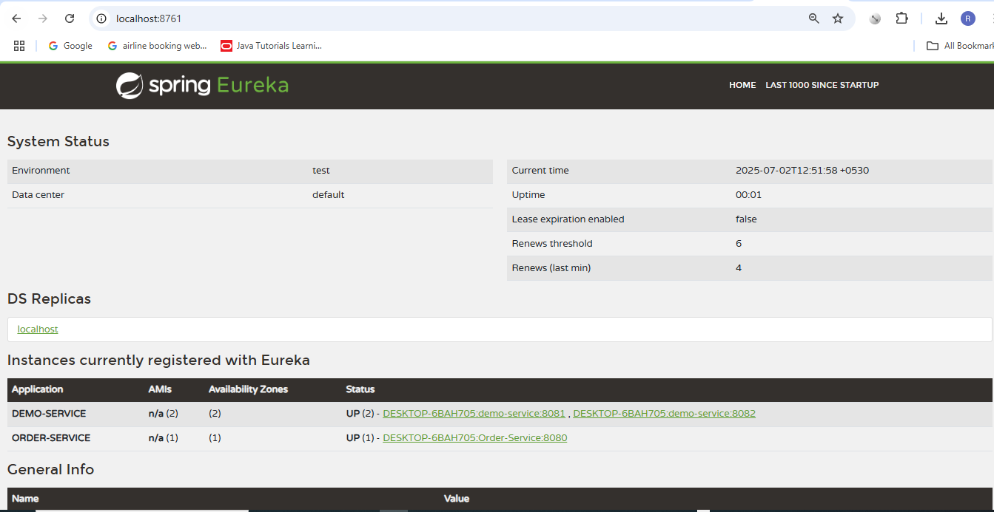

✅ 3️⃣ Run order-service
bash
CopyEdit
cd D:\spring-project\Java-project\order-service
mvn spring-boot:run
✅ Starts on http://localhost:8080

🔥 Now test the full flow
Go to Postman or your browser:
GET http://localhost:8080/order
✔ Every time you call this:
- order-service asks Eureka: "Give me a DEMO-SERVICE".
- Eureka returns 8081 or 8082.
- LoadBalancer alternates them.

So you’ll see:
Order placed for -> Product data served from port: 8081
Order placed for -> Product data served from port: 8082
...

